Guide for TopSpin 1.3 (300 MHz) Version 1.0

This guide gives a description on how to obtain 1D spectra on the 300 MHz instrument. For a more comprehensive guide, please see Topspin manuals available in the lab, or at the Bruker Biospin web page (requires log in).

Text highlighted in red is safety information (the spectrometer’s safety, not yours).

Text highlighted in yellow, are commands that should be entered into the input prompt at the lower end of the TopSpin window.

**THE NMR SPECTROMETER IS A VERY DELICATE PIECE OF EQUIPMENT. MALOPERATION CAN CAUSE SERIOUS DAMAGE AND EXPENSIVE REPAIRS, SO PLEASE ASK TOO FREQUENTLY RATHER THAN TOO LITTLE!**

For users familiar with Xwinnmr, most of the old commands used for both acquisition and processing are still used under Topspin.

Log on to the workstation using your personal username / password. The topspin program is found under Applications/BRUKER. The topspin window looks like this:

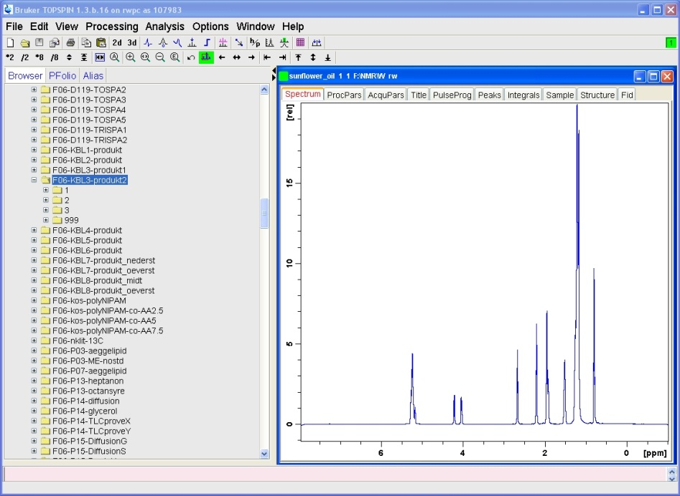

Input prompt/command line

Status line

Spectrum window

Dataset browser

buttons

Insert your sample in the blue spinner. For temperatures between 50 – 100 oC, use the gray spinner. Use the depth gauge (1.8 cm) to assure optimal alignment of the sample vs the coils. Wrong settings of the depth could damage the probe! Also, do NOT insert the depth gauge into the magnet!

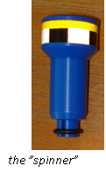

Blue spinner

Before approaching the magnet, make sure you leave behind key cards, memory sticks, cell phones or any other magnetically based storage devices or loose ferrometallic objects.

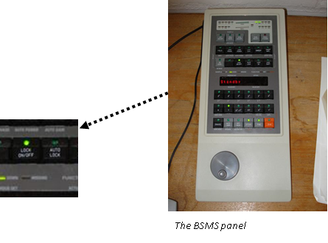

Press lift on/off (BSMS-panel) and place the sample (with spinner) on top of the magnet when you can hear the air flowing. Do not drop the sample before it “floats” on the airflow. Again press “lift on/off” (BSMS) to lower the sample.

Temperature adjustment

Type edte to change temperature. The maximum allowed temperature is 100 oC and it is advised to reduce gas flow to 270 l/h when working at high temperatures. Remember to set the temperature back to 25 oC when finished, and in good time before the next user will use the instrument. The instrument and sample needs time to adjust to new temperature settings.

Low temperature requires liquid nitrogen and such experiments must be planned and performed together with trained lab personnel.

Setting up a new experiment

First op an old dataset from the dataset browser. Then type edc.

- enter an experiment NAME (should not contain special characters or SPACE)

- enter experiment number (EXPNO) (preferably start with 1 and number successively)

- leave PROCNO at 1 unless you know what you are doing

- leave DIR as it is (opt/topspin)

- enter your login name in USER field

- choose solvent from list

- choose experiment parameters from list (standard parameters will be named nt_***)

- enter a title for the spectrum (title will appear on the spectrum and on printouts)

Parameter adjustment

If you need to adjust any of the parameters (experienced users), these are easily available from the top of the spectrum window. Essential parameters for 1D experiments are o1p (center of spectrum in ppm) and sw (spectral width in ppm). Number of scans can be adjusted with ns. To see how long the experiment will take, type expt.

Tuning and matching

Type wobb to start tuning and matching procedure. Adjust the appropriate rods under the magnet (yellow for 1H, red for 13C/15N/31P) so that the tip of the wobble signal is positioned where the two axis meet (also shown as all green LEDs on the preamplifier). If you are tuning 13C/15N/31P, make sure the correct nucleus has been chosen on the preamplifier. Click or type stop to end this procedure when the signal looks good.

Locking

Type lockdisp to open the lock display. Type lock and choose the correct solvent. Lock sometimes fail if current shim is bad. In this case choose a new shim file (see below) and repeat lock command.

If signal looks unstable try pressing “LOCK PHASE” on BSMS and maximize the lock signal by turning the wheel. Press “STD BY” on BSMS.

Shimming

Read the newest shim file associated with your solvent by typing rsh. Shim files are stored in the format “solvent_date” (ex. CDCl3_250311).

Press Z on BSMS and turn the wheel to adjust shim. Try to maximize the amplitude of the lock signal. If the signal leaves the lockdisp window, press “LOCK GAIN” and use the wheel to bring the signal back down. When Z-shim is optimized, move on to Z2 and repeat procedure. Keep alternating between Z and Z2 until the lock signal is optimized. Press “STD BY” when finished.

A similar shim procedure can be done on X and Y, although in most cases this should not be required.

Receiver gain and start aquisition

Type rga for receiver gain adjustment. Wait for message “rga finished”.

Start experiment by typing zg

If you are running a 13C experiment and want to see if you have acquired enough signal, type tr, wait for “checklockshift finished” message and then ft for Fourier transformation. Type halt to end the experiment. The command stop will end the experiment without saving the data!

When experiment is finished, press LOCK on BSMS to turn off lock and remove your sample. If you want to process your data on the workstation, keep reading. Otherwise remember to close the programs and log out.

Processing

Fourier transformation

Fourier transform your 1D spectra by typing ft. If you want to use exponential or Gaussian multiplication use commands em or gm respectively (the relevant parameters are found under the Procpars menu).

Phase correction

Use apk for automatic phase correction. If you are not satisfied, use manual phase correction by pressing the phase correction button



There is now a red vertical line going through the biggest peak. Choose a peak that is standing for itself, close to the edge of the spectrum. Right click on the peak and choose “Set Pivot Point”. The red line will move to this peak. Inside the spectral window there are now some new buttons.

Press and hold the “0” button and move mouse up or down until the peak looks symmetrical. Press and hold the “1”button and move mouse until the other peaks look symmetrical (it is easiest to look at a peak on the opposite side of the first peak). When content, press save&return



Calibration

If sample contains TMS and no other peaks are found close to the TMS-peak, type sref for automatic calibration. Otherwise, zoom in on a peak with known shift (like the solvent) and press the calibrate button



Click on the peak, and a window pops up where you can enter the shift.

Baseline correction

Automatic baseline correction is performed by typing abs (this also performs automatic integration). If you are not satisfied, you can find more options by pressing the baseline button (experienced users) .



Integration

Press the integrate button



zoom into your spectrum, click the “define integration regions interactively” button , the button turns green () and define the regions by clicking (left mouse button) and dragging in the spectrum.



calibrate your integrals by right-clicking on an integral with known area and choose “Calibrate” from the pop-up menu. Enter the area of this peak. All other integrals will be adjusted accordingly.

when finished, press the “save and return” button



Plotting

Simple way: type print, the spectrum will be printed as you see it on the screen.

More advanced: type xwp, this opens the xwinplot editor which allows customized printouts.

Remember to close the programs and log out when you are finished.