Guide for TopSpin 2.1 (600 MHz) Version 1.0

This guide gives a description on how to obtain NMR spectra on the 600 MHz instrument. For a more comprehensive guide, please see Topspin manuals available in the lab, or at the Bruker Biospin web page (requires log in).

Text highlighted in red is safety information (the spectrometer’s safety, not yours).

Text highlighted in yellow, are commands that should be entered into the input prompt at the lower end of the TopSpin window.

**THE NMR SPECTROMETER IS A VERY DELICATE PIECE OF EQUIPMENT. MALOPERATION CAN CAUSE SERIOUS DAMAGE AND EXPENSIVE REPAIRS, SO PLEASE ASK TOO FREQUENTLY RATHER THAN TOO LITTLE!**

For users familiar with Xwinnmr, most of the old commands used for both acquisition and processing are still used under Topspin.

Log on to the workstation using your personal username / password. The topspin program is found under Applications/BRUKER. The topspin window looks like this:

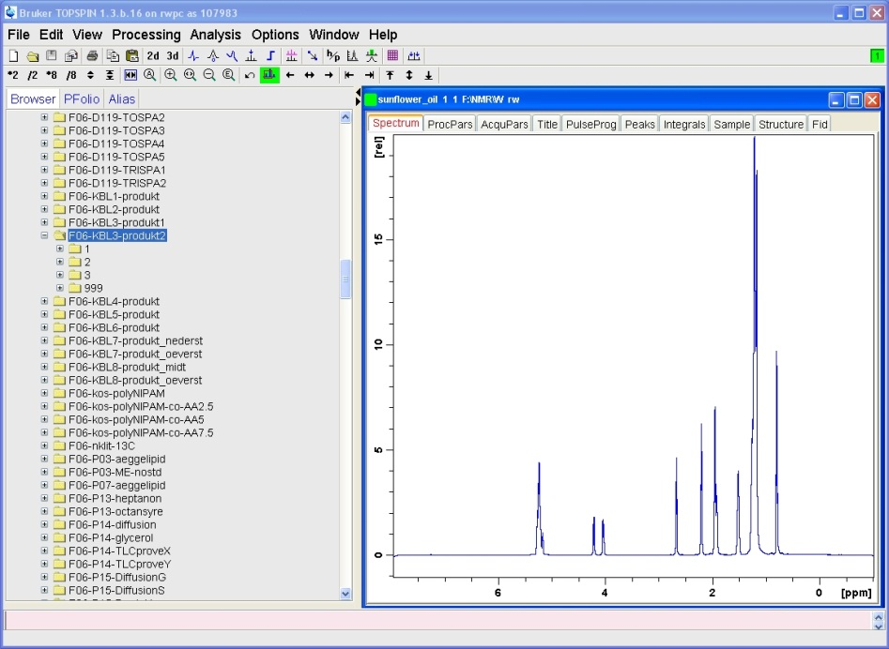

Input prompt/command line

Status line

Spectrum window

Dataset browser

buttons

Insert your sample in the heavy hvite spinner reserved for the 600 MHz instrument. Use the depth gauge (2.0 cm) to assure optimal alignment of the sample vs the coils. Wrong settings of the depth could damage the probe! Also, do NOT insert the depth gauge into the magnet!

Before approaching the magnet, make sure you leave behind key cards, memory sticks, cell phones or any other magnetically based storage devices or loose ferrometallic objects.

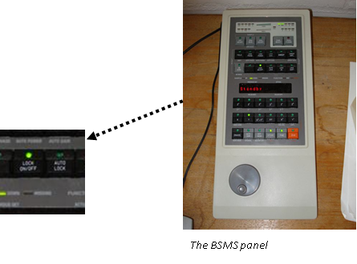

Press lift on/off (BSMS-panel) and place the sample (with spinner) on top of the magnet when you can hear the air flowing. Do not drop the sample before it “floats” on the airflow. Again press “lift on/off” (BSMS) to lower the sample.

Temperature adjustment

Type edte to change temperature. The allowed temperature range is 0 - 60 oC. Remember to set the temperature back to 25 oC when finished, and in good time before the next user will use the instrument. The instrument and sample needs time to adjust to new temperature settings.

Setting up a new experiment

First op an old dataset from the dataset browser. Then type edc.

- enter an experiment NAME (should not contain special characters or SPACE)

- enter experiment number (EXPNO) (preferably start with 1 and number successively)

- leave PROCNO at 1 unless you know what you are doing

- leave DIR as it is (opt/topspin)

- enter your login name in USER field

- choose solvent from list

- choose experiment parameters from list (parameter files will be named nt_***)

- enter a title for the spectrum (title will appear on the spectrum and on printouts)

Parameter adjustment

If you need to adjust any of the parameters (experienced users), these are easily available from the top of the spectrum window. Essential parameters for 1D experiments are o1p (center of spectrum in ppm) and sw (spectral width in ppm). Number of scans can be adjusted with ns. To see how long the experiment will take, type expt. Wrong settings of the parameters can damage the probe! Do not change anything unless you know exactly what you are doing.

Tuning and matching

Type wobb to start tuning and matching procedure. Adjust the appropriate rods under the magnet (yellow for 1H, red for 13C, blue for 15N) so that the tip of the wobble signal is positioned where the two axis meet (also shown as all green LEDs on the preamplifier). Click or type stop to end this procedure when the signal looks good.

Locking

Type lockdisp to open the lock display. Type lock and choose the correct solvent. Lock sometimes fail if current shim is bad. In this case choose a new shim file (see below) and repeat lock command.

If signal looks unstable try pressing “LOCK PHASE” on BSMS and maximize the lock signal by turning the wheel. Press “STD BY” on BSMS.

Shimming

Type topshim. Shimming will be done automatically.

Receiver gain and start aquisition

Type rga for receiver gain adjustment. Wait for message “rga finished”.

Start experiment by typing zg

If you are running a 13C experiment and want to see if you have acquired enough signal, type tr, wait for “checklockshift finished” message and then ft for Fourier transformation. Type halt to end the experiment. The command stop will end the experiment without saving the data!

When experiment is finished, press LOCK on BSMS to turn off lock and remove your sample. Remember to close the programs and log out.

Processing

Data may be processed at the work station, but to ensure optimal use of the instrument we encourage users to download the data to their own personal computers and use appropriate processing software.