Lab rules

SABA

Structure Aspects of Biomolecules Activity group

K-3: rooms 419 og 417

1. Common rules for the institute

2. Specific rules for SABA

3. Signature and receipt

1. General rules for IBT

1. Protective equipment

- Gloves must be used when necessary. Take them off when the lab work has ended or when you leave the lab.

- Eye protection must be used in areas where it is mandatory or when there is a risk of injury to eyes (e.g. corrosive chemicals or high/low pressure). The NT-faculty has a written an eye protection regulation (the faculty’s web).

- Ventilation hoods/ spot hoods must be used when working with volatile, hazardous or malodorous chemicals.

2. Equipment and chemicals

- Overview of IBT’s chemicals with material safety data sheet (MSDS) can be found in NTNU’s electronic chemical register, Ecoonline (My bookmarks → organizational → Fakultet for Naturvitenskap og Teknologi → stoffkartotek). Paper copies in Norwegian and English are located in relevant labs. Users of chemicals must check the MSDS information.

- The technical staff routinely prepares stock solutions of chemicals that are documented with weight forms. Everybody that prepare these solutions must use weight forms (e.g. if we run out and the technical staff does not have capacity to supply in short notice). Empty forms can be found in binders in lab. Forms that are filled out should be archived in these binders.

- Room U07 in Kjemiblokk 3 is used for common storage of chemicals. Used the log book when borrowing/ removing chemicals.

- It is everybody’s responsibility to order common chemicals and equipment before we run out. If relevant, inform the room administrator or supervisor. It may take a while to receive supply.

- Orders are sent to IBTs ordering staff (”fagbestillere”) by electronic requisition forms. See innsida: My bookmarks → organizational → Institutt for Bioteknologi → Routines → Bestillingsrutiner.

- Registrations of chemicals that are emptied or disposed and not replaced must be removed from Ecoonline. Empty original packing (boxes etc.) must in such cases be labelled with Ecoonline location and placed in collection boxes/ trays in room K3-403 (Kjemiblokk 3) or D1-174 (Realfagbygget)

- Chemicals in the categories ”toxic”, ”very toxic” or ”explosive” must be secured from public access in cabinets, fridges etc. with locks or in or safes.

- Stock-chemicals in unoriginal packing must be labeled according to local routines (se innsida: My bookmarks → organizational → Institutt for Bioteknologi → HSE (Health, safety and environment → Merking). Other goods (ager plates, samples etc.) must be labeled with date and name. Unlabelled goods will be discarded.

- In order to identify owners of chemicals and goods, each lab has an initial list for the users (e.g. “EDE” = Emanuel Desperado).

- Always use log books when established.

3. Behaviour in lab

- Eating and drinking in lab is prohibited

- Keep the lab tidy and clean

- Don not contaminate stock chemicals: Never return chemicals to the stock container and always use clean spatulas

- Confer the room administrator (romansvarlig) before you borrow/ remove equipment

- It is prohibited to work alone outside normal working hours in case there is a rask for acute health injury that prevents call for help (e.g. entry to the -40 C room, working with cyanides). See risk assessment.

- Contact room administrator if you plan activity that is not in accordance with information from the room card.

- Report aberration by the electronic aberration form (NT-faculty’s web pages)

4. Risk assessments

- All activity at IBT should be subjected to risk assessment. The project leader is responsible for the preparation of risk assessment documentation for activities with risk. Risk assessments and operating instructions are archived and accessible on innsida (My bookmarks → organizational → Institutt for Bioteknologi → HSE Health, safety and environment → Risikovurderinger IBT)

- Everybody that starts working in lab should send the following to the HSE-coordinator:

- Risk mapping and risk assessments

- Signed documentation for guiding and training in lab (last chapter in this document).

5. HSE-contact persons

- Leaders in all levels (including. Project leaders and supervisors) are responsible for the lab security.

- HSE-coordinator, safety deputy, room administrators.

- Other roles can be found on innsida (My bookmarks → organizational → Institutt for Bioteknologi → HSE Health, safety and environment → Organisering)

6. HSE-information

- Fire instructions (building)

- Room cards (room)

- Material safety data sheets (chemicals)

- HSE-info can be found at innsida:

  - My bookmarks → organizational → Institutt for Bioteknologi
  - My bookmarks → organizational → Fakultet for Naturvitenskap og Teknologi

2. Specific rules for SABA

Principal Investigator Associate prof. Alexander Dikiy
alex.dykyy@biotech.ntnu.no tel: (735) 978 63; 46 47 06 17 (mob)
- Ensure laboratory workers attend general lab safety rules.
- Review and approve work with particularly hazardous substances.

Laboratory Worker Elena Shumilina, Olena Dobrovolska
elena.shumilina@biotech.ntnu.no;
olena.dobrovolska@biotech.ntnu.no;

- Attend laboratory safety training.
- Review the SABA safetly rules.
- Follow procedures and SABA laboratory practices.
- Use engineering controls and personal protective equipment, as appropriate.
- Report all incidents, accidents and potential chemical exposures to the principal investigator and the overingeniør, responsible for the technical safety.
- Document specific operating procedures for work with particularly hazardous substances, including carcinogens, reproductive toxins and chemicals with high acute toxicity.

- Laboratory experimentss should be read before the laboratory period and work should be planned.
- Report all accidents to the instructor immediately.
- Do not engage in practical jokes or boisterous conduct in the laboratory.
- Never run in the laboratory.
- The use of personal audio or video equipment is prohibited in the laboratory.
- The performance of unauthorized experiments is strictly forbidden.
- Do not sit on laboratory benches
- Before leaving the laboratory, electrical equipment should be turned off, and gas burners extinguished. No tap water should be left running.

Laboratory Equipment

Laboratory ventilation

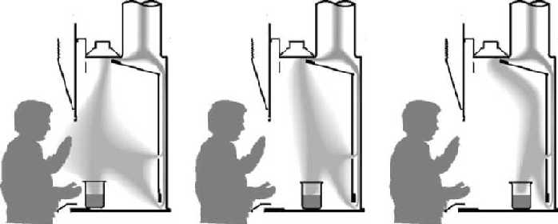

Bad placement of materials. | Good placement of materials. | Best placement of materials.

- Items with odorous or hazardous materials should be removed from the hood
only after decontamination or if placed in a closed outer container
to avoid releasing contaminants into the laboratory air.
- Keep the sash completely lowered
any time an experiment is in progress and the hood is unattended.
Note: Lowering the sash not only provides additional personal protection,
but it also results in significant energy conservation.

- Do not use the hood as a storage device.
- Keep only the materials necessary for the experiment inside of the hood.
If chemicals must be stored in the hood for a period of time,
keep it on the shelves on the sides of the hood.
- Keep the hood sash clean and clear.
- Extend only hands and arms into the hood and avoid leaning against it.
- Clean all chemical residues from the hood chamber after each use.
- All electrical devices should be connected outside the hood
to avoid electrical arcing that can ignite a flammable or reactive chemical.
MALDI TOF-TOF
MALDI must be operated only by trained personal.
Microwave Ovens
- As with most electrical apparatus, there is the risk of generating sparks that can ignite flammable vapors.
- Metals placed inside the microwave oven may produce an arc that can ignite flammable materials.
- Materials placed inside the oven may overheat and ignite.
- Sealed containers, even if loosely sealed, can build pressure upon expansion during heating, creating a risk of container rupture.
- Do not place wires and other objects between the sealing surface and the door on the oven’s front face. The sealing surfaces must be kept absolutely clean.
- Never use a microwave oven for both laboratory use and food preparation.
- Do not use metal-containing objects (e.g., stir bars) in the microwave. They can cause arcing.
- Do not heat sealed containers in the microwave oven. Even heating a container with a loosened cap or lid poses a significant risk since microwave ovens can heat material so quickly that the lid can seat upward against the threads and containers can explode.
- Remove screw caps from containers being microwaved. If the sterility of the contents must be preserved, use cotton or foam plugs.

Electrophoresis Devices
- Turn the power OFF before connecting the electrical leads
- Connect one lead at a time, using one hand only
- Ensure that hands are dry while connecting leads
- Keep the apparatus away from sinks or other water sources
- Turn OFF power before opening lid or reaching inside chamber
- Do not override safety devices
- Do not run electrophoresis equipment unattended.
- If using acrylamide, purchase premixed solutions or pre-weighed quantities whenever possible
- If using ethidium bromide, have a hand-held UV light source available in the laboratory. Check working surfaces after each use.
- Mix all stock solutions in a chemical fume hood.
- Provide spill containment by mixing gels on a plastic tray
- Decontaminate surfaces with ethanol. Dispose of all cleanup materials as hazardous waste.
Ultrasonicators

Ultrasound through airborne conduction does not appear to pose a significant health hazard to humans. However, exposure to the associated high volumes of audible sound can produce a variety of effects, including fatigue, headaches, nausea and tinnitus. When ultrasonic equipment is operated in the laboratory, the apparatus must be enclosed in a 2-cm thick wooden box or in a box lined with acoustically absorbing foam or tiles to substantially reduce acoustic emissions (most of which are inaudible).
Direct contact of the body with liquids or solids subjected to high-intensity ultrasound should be avoided. Under sonochemical conditions, cavitation is created in liquids, and it can induce high-energy chemistry in liquids and tissues. Cell death from membrane disruption can occur even at relatively low acoustic intensities.
Exposure to ultrasonically vibrating solids, such as an acoustic horn, can lead to rapid frictional heating and potentially severe burns.

- Do not hold in your hands the sample during sonications.

Centrifuges

Centrifuges should be properly installed and must be operated only by trained personal. It is important that the load is balanced each time the centrifuge is used and that the lid be closed while the rotor is in motion. The disconnect switch must be working properly to shut off the equipment when the top is opened, and the manufacturer’s instructions for safe operating speeds must be followed.

- Keep used rotors at 4ºC (cold room).

- Use only special centrifuge tubes for high speed. Not adapted tubes can break and you will lose the sample.

- Be careful during bacterial material centrifugation. In the case of biological contamination rotor have to be autoclave and washed.

- Clean the centrifuge after use.

Stirring and Mixing Devices
- The stirring and mixing devices include magnetic stirrers and shakers.
- If stirring and mixing devices are operated for fairly long periods without constant attention, the consequences of stirrer failure, electrical overload or blockage of the motion of the stirring impeller should be considered.
- Never leave ON magnetic stirrers after use.
- If you use magnetic stirrers in Cold room check if heater is switch OFF.

Autoclaves

The use of an autoclave is a very effective way to decontaminate infectious waste. Autoclaves work by killing microbes with superheated steam.

- Do not put sharp or pointed contaminated objects into an autoclave bag. Place them in an appropriate rigid sharps disposal container.
- Use caution when handling an infectious waste autoclave bag.
- Do not overfill an autoclave bag. Steam and heat cannot penetrate as easily to the interior of a densely packed autoclave bag.
- Use indicator tape with each load to verify it has been autoclaved.
- Do not mix contaminated and clean items together during the same autoclave cycle. Clean items require shorter decontamination times (15-20 minutes) while a bag of infectious waste requires 45 minutes to an hour to be effectively decontaminated.
- Always wear personal protective equipment, including heat-resistant gloves, safety glasses and a lab coat when operating an autoclave. Use caution when opening the autoclave door. Allow superheated steam to exit before attempting to remove autoclave contents.
- Be on the alert when handling pressurized containers. Superheated liquids may spurt from closed containers. Never seal a liquid container with a cork or stopper. This could cause an explosion inside the autoclave.
- Agar plates will melt and the agar will become liquefied when autoclaved. Avoid contact with molten agar. Use a secondary tray to catch any potential leakage from an autoclave bag rather than allowing it to leak onto the floor of the autoclave chamber.
- If there is a spill inside the autoclave chamber, allow the unit to cool before attempting to clean up the spill. If glass breaks in the autoclave, use tongs, forceps or other mechanical means to recover fragments.
- Do not to leave an autoclave operating unattended for a long period of time. Always be sure someone is in the vicinity while an autoclave is cycling in case there is a problem.
Refrigerators and Freezers

- Only chemicals should be stored in chemical storage refrigerators

- Lab refrigerators should not be used for food storage or preparation

- All materials in refrigerators or freezers should be labeled with the contents, owner, date of acquisition or preparation and nature of any potential hazard.

- Labels and ink used to identify materials in the refrigerators should be water-resistant.

- All containers should be sealed, preferably with a cap.

Safe Work Practices and Procedure
Chemical Storage
Store materials and equipment in cabinets and on shelving provided for such storage.
- Avoid storing materials and equipment on top of cabinets.
- Be sure that the weight of the chemicals does not exceed the load capacity of the shelf or cabinet.
- Do not store materials on top of high cabinets where they will be hard to see or reach.
- Do not store corrosive liquids above eye level.
- Provide a specific storage location for each type of chemical, and return the chemicals to those locations after each use.
- Avoid storing chemicals in the workspace within a laboratory hood, except for those chemicals currently in use.
- If a chemical does not require a ventilated cabinet, store it inside a closable cabinet or on a shelf that has a lip to prevent containers from sliding off in the event of an accident or fire.
- Do not expose chemicals to heat or direct sunlight.
- Observe all precautions regarding the storage of incompatible chemicals.
- Use corrosion resistant storage trays or secondary containers to collect materials if the primary container breaks or leaks.
- Do not store flammable liquids in a refrigerator unless it is approved for such storage. Such refrigerators are designed with non-sparking components to avoid an explosion.

Segregation of Chemicals
Incompatible chemicals should not be stored together. Use common sense when setting up chemical storage. Segregation that disrupts normal workflow can increase the potential for spills.
There are several possible storage plans for segregation. In general, dry reagents, liquids and compressed gases should be stored separately, then by hazard class.
Lable all solutions made in the laboratory.

Chemical Incompatibility Chart
Mixing these chemicals purposely or as a result of a spill can result in heat, fire, explosion, and/or toxic gases. This is a partial list.
Acetic Acid | Chromic Acid, nitric acid, hydroxyl-containing compounds, ethylene glycol, perchloric acid, peroxides, and permanganates.
Acetone | Bromine, chlorine, nitric acid, sulfuric acid, and hydrogen peroxide.
Ammonia (anhydrous) | Bromine, chlorine, calcium hypochlorite, hydrofluoric acid, iodine, mercury, and silver.
Ammonium Nitrate | Acids, metal powders, flammable liquids, chlorates, nitrates, sulfur and finely divided organics or other combustibles.
Carbon (activated) | Calcium hypochlorite, all oxidizing agents.
Caustic (soda) | Acids (organic and inorganic).
Flammable Liquids | Ammonium nitrate, chromic acid, hydrogen peroxide, nitric acid, sodium peroxide, bromine, chlorine, fluorine, iodine.
Hydrofluoric Acid | Ammonia, aqueous or anhydrous.
Nitrates | Combustible materials, esters, phosphorous, sodium acetate, stannous chloride, water, zinc powder.
Nitric acid (concentrated) | Acetic acid, acetone, alcohol, aniline, chromic acid, flammable gases and liquids, hydrocyanic acid, hydrogen sulfide and nitratable substances.
Sulfuric Acid | Chlorates, perchlorates, permanganates, compounds with light metals such as sodium, lithium, and potassium.
Water | Acetyl chloride, alkaline and alkaline earth metals, their hydrides and oxides, barium peroxide, carbides, chromic acid, phosphorous oxychloride, phosphorous pentachloride, phosphorous pentoxide, sulfuric acid, sulfur trioxide.

Flammable Liquids
Flammable liquids are store under the hood.
Acids
Mineral acids, including phosphoric, hydrochloric, nitric and sulphuric acid are stored under the hood.
Concentrated acids can even react vigorously with dilute solutions of the same acid, if mixed together rapidly. For example: concentrated sulfuric acid mixed quickly with 1 molar sulfuric acid will generate a lot of heat.
Acetic acid is an organic acid and should be stored separately from mineral acids. Since it is also flammable, it is best stored with other flammable liquids.

Compressed Gases
Compressed gases pose a chemical hazard due to the gases themselves and a high energy source hazard due to the great amount of pressure in the cylinder.
- All cylinders must be secured to a wall.

Combustible Materials
Common combustible materials, such as paper, wood, corrugated cardboard cartons and plastic labware, if allowed to accumulate, can create a significant fire hazard in the laboratory. Combustible materials not stored in metal cabinets should be kept to a minimum. Clean the lab from useless paper boxes and containers.

Transporting Chemicals
Spills and chemical exposure can occur if chemicals are transported incorrectly, even when moving chemicals from one part of the laboratory to another. To avoid this type of incident, consider the following:
- Use a bottle carrier, cart or other secondary container when transporting chemicals in breakable containers (especially 250 ml or more). Secondary containers are made of rubber, metal or plastic, with carrying handle(s), and are large enough to hold the entire contents of the chemical containers in the event of breakage.
- When moving in the laboratory, anticipate sudden backing up or changes in direction by others. If you should stumble or fall while carrying glassware or chemicals, try to project them away from yourself and others.
- The individual transporting the chemical should be knowledgeable about the hazards of the chemical and should know how to handle a spill of the material.
- When transporting compressed gas cylinders, the cylinder should always be strapped in a cylinder cart and the valve protected with a cover cap. Do not attempt to carry or roll cylinders from one area to another.
- Keep chemicals in their original packing when transporting, if possible.

Working Alone
Individuals using hazardous chemicals should not work alone. Another individual capable of coming to the aid of the worker should be in visual or audio contact.
- If working alone is absolutely necessary, the worker should have a phone immediately available and should be in contact with another person (who knows that he or she is being relied upon) at least every 30 minutes.
- If no one from the laboratory is available, the worker should coordinate with another person in the building to check in on them periodically.
Autoclaving:
- Mark the things to be autoclaved with content, date, name and autoclave tape.
- Don’t fill the bottles too full, they may boil over in the autoclave. Agar media should make up maximum 50 % of the bottles total volume. Never tighten the screw-cap so that vapor cannot escape – bottles may explode or the screw-cap may be damaged due to increased pressure.
- Solutions and items for autoclaving are stored in a box labeled “Til autoklavering” when the autoclave is occupied. Be sure that you choose the right program when starting.
- Solutions that are autoclaved are put in the box marked ”ferdig autoklavert” and is collected by the owners as soon as possible.
- Waste that contain organic solutions (for instance DMSO) must not be autoclaved.

Waste:
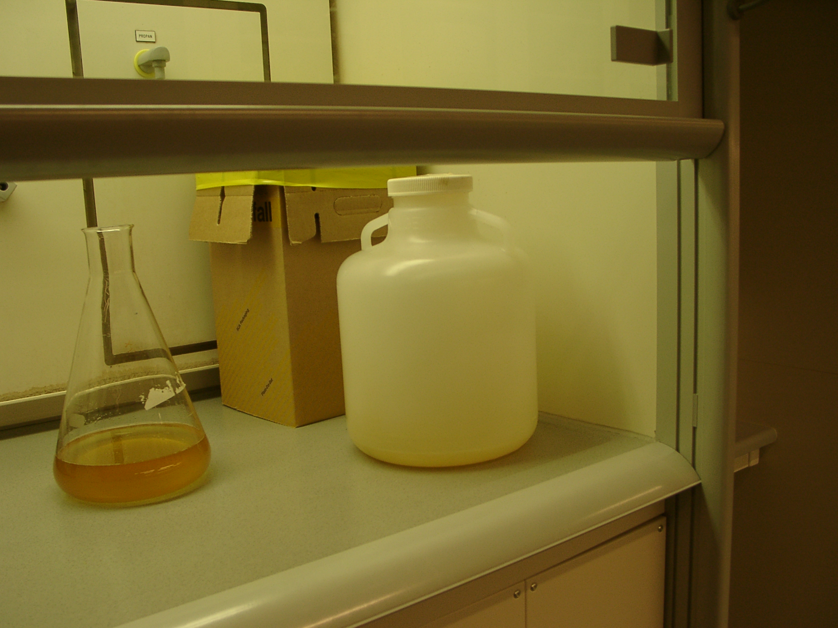
- Liquid microorganism-waste (e.g. cultures), including GMM, should be collected in tanks that are placed in all labs (picture). Liquid waste is routinely autoclaved by the technicians (1 h, 120 C).

- Microorganism waste, including GMM, that cannot be autoclaved, must be inactivated chemically, normally by addition of NaOH to > 0,5 M, incubation > 24 h. If this protocol is not suitable (e.g. spores), the project must identify satisfactory protocols.
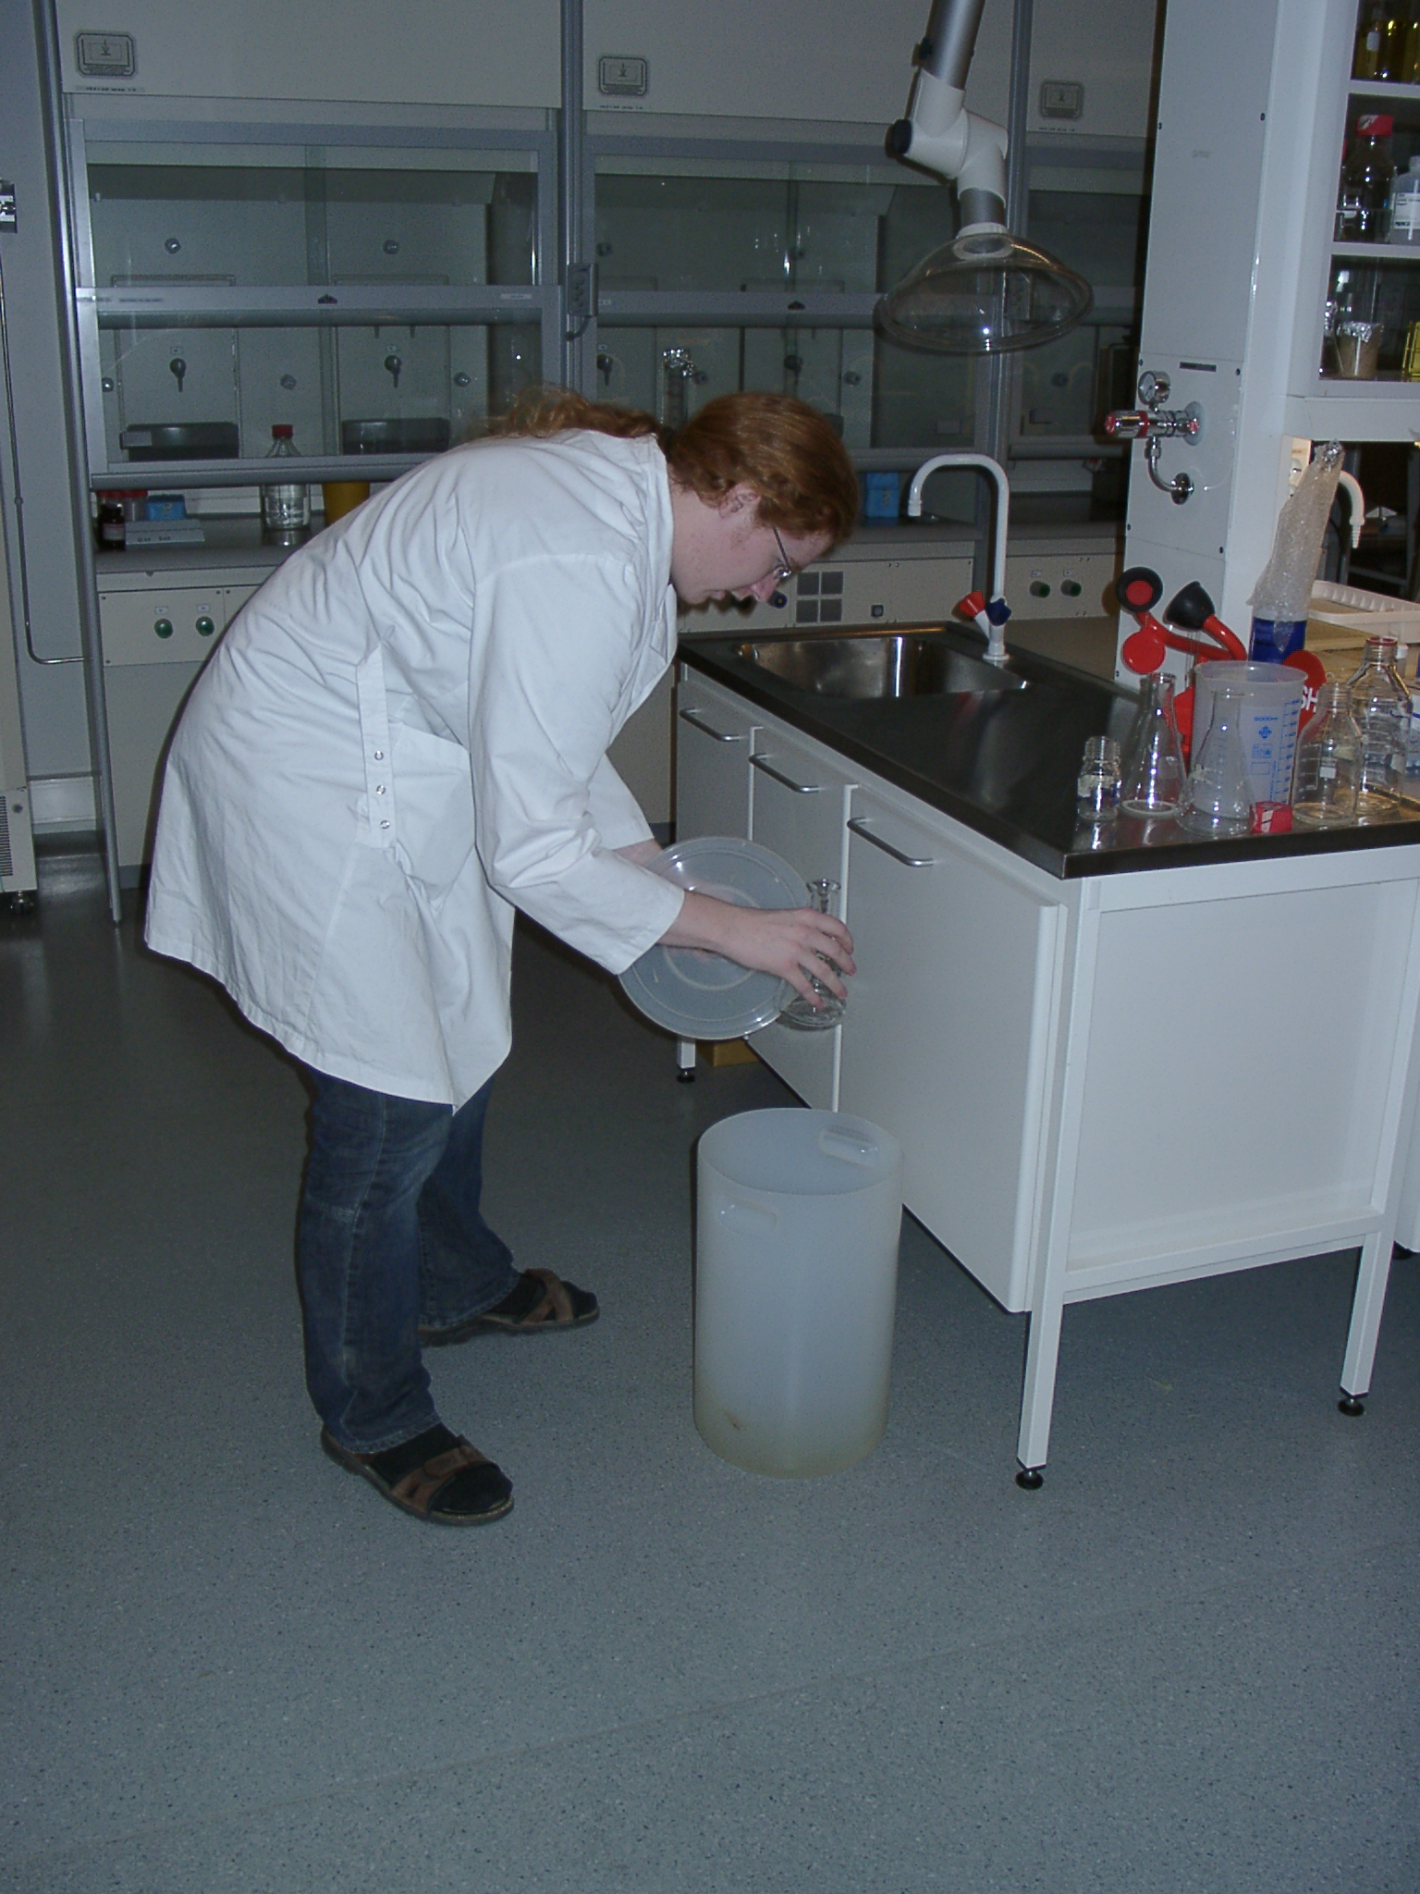
- Glass-equipment and plastic equipment meant to be used several times, like centrifuge-cups, that are contaminated with bacteria shall be placed in the small plastic buckets on the lab, for autoclaving. Remove the wadding and the screw cap before putting the equipment in the buckets.

- The wadding-tops should be put in an own collection basket on top of the sink.
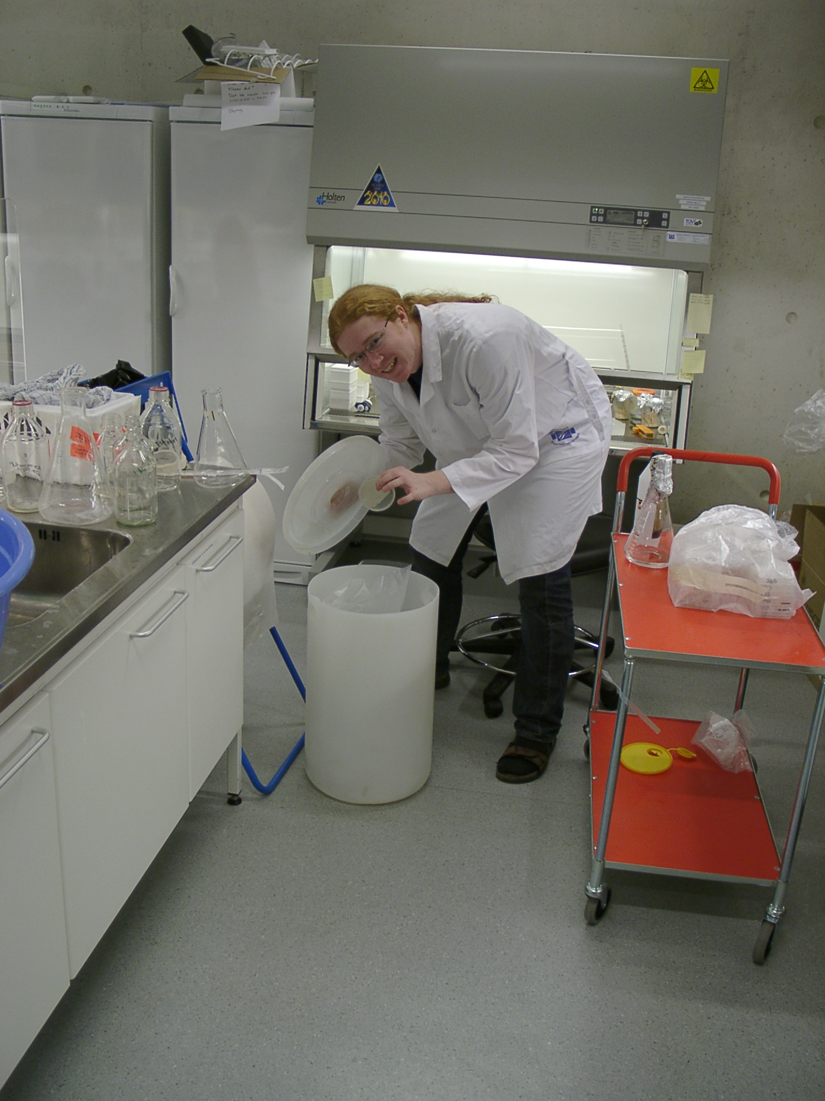
- Solid bacteria waste and plastic equipment for single time use that have been contaminated with bacteria is thrown away in plastic buckets with an autoclave bag. They will be autoclaved at 120 C for one hour. (Don’t fill the bags too full).

- Paper waste and other non-contaminated waste, except single use pipets, is put into the ordinary black refuse bag.

- Single use pipets that is not used for bacteria- or risk- waste is put into the same container as generally dirty glassware.

- Risk-waste (except bacteria waste) is thrown into the red risk-waste- box. (red plastic box) placed in the ventilation hoods at every lab.

- Remember to put organic solvents into the collection bottles in the ventilation hood in the kitchen K-425. Separate between organic chemicals with and without halogens. Declare the date, volume and contents of your waste on the list on the front of the hood where you find the waste buckets.

- Broken glassware should be thrown into the waste container for broken glassware. (cardboard box with black plastic bag).

- Dirty glassware is rinsed and put in the tub for washing. Stickers / tape must be be removed. Autoclave tape can be removed with plastic removal agent.

- It is not allowed to pour liquid agar in the sink. Then the sink tightens. Pour the agar into a beaker and wait until it has solidified. Non-contaminated agar is put into the black waste bags. Contaminated agar is put to waste into the big white plastic containers for bacteria waste.

- Ethanol bottles should be placed in the ventilation hood when not in use. It is due to the fire safety rules. Maximum two 1 liter bottles with 96% ethanol is allowed to be in the ventilation hoods in one lab. If the bottles are empty contact the technical staff for supply.

- Ask somebody if you are uncertain of how things should be thrown to waste. It is better to ask than to do mistakes.

- Order and tidiness

Each person is responsible for keeping both their own working space and used common working areas tidy and clean.
3. Signing of and receipt

Lab rules for the SABA group and guiding in K-3: rooms 419, 425,417,403

I, ______________________ , have read and understood the lab rules and

_________________________ has been responsible for the mandatory guiding in lab

Date/ signature:____________________________
Trained/ guided person

Date/ Signature:____________________________
Responsible for guiding
Cross out:
□ I confirm that (1) documentation for mapping of activities and risk assessments for planned activities have been sent to the HSE-coordinator and that (2) risk assessment for new activities have been sent to archive-administrator.

Date/ signature:____________________________
Trained/ guided person

Date/ signature:________________________________________________________
Supervisor

Send this document (signed) to the HSE-coordinator
□ Controlled by the head of the institute: Date/ Signature:____________________________

